The Worship of Our God
Resting in the Renewing Power of God’s Grace

May 3rd, 2020

The Fourth Sunday in Easter!

Prelude
Welcome, announcements and Call to Worship

*Opening Hymn #509: “In Christ There is no East or West” (G)

Invocation
Passing of the Peace
Leader: May the peace of Christ be with you
People: And also, with you,
Hymn #499 “Am I a Soldier of the Cross” (G)
Our Confession to God
Our Assurance of Forgiveness
Our Petitions to God
Pastoral Prayer / The Lord’s Prayer
Tithes and Offerings

*Confession of Faith “The Apostles Creed” (I)

The Equipping of God’s People

Scripture Genesis 22:15-19, Matthew 28:16-20
Message The Irreducible Core Part 3: “Make Disciples”

*Closing Hymn: Facing a Task Unfinished

Benediction
Postlude

Pastor Jonathan Faulkner
Accompanist: Kathi Nelson, Phyllis Shortenhaus, Rachel Faulkner & Mary Haakenson
The People of God, Ministers to the World
*Indicates standing (G) Green Hymnal (P) Purple Chorus Book (I) Insert

Welcome! We are so thankful that you could join us today! May our hearts and minds be shaped into greater conformity with Jesus as we worship together. We are delighted to serve you as we love one another in Christ.

Faithful in Prayer
Praise the Lord for…
- His grace in preaching, prayer, the sacraments & fellowship
- The beauty of creation & His divine imprint on all that He has made
- His powerful & life-giving Word

Hospitalized, Sick or Shut-in
* Marlyn Hanson
* Jan Missman
- Jenny Frerichs
- Leone Milbrandt
- Carol Malmberg
- Larry Dirksen
- Jack Jutting
- Chuck Silber
- The Family of Elizabeth Van Eyll
- Connie Berhow
- John Davids
- Billy Smith
- Dale Heitland
- Richard Heyes
- Travis Stohr
- Kim Enright
- Jeff Buege
- Colt (Paul and Cheryl Beenken’s grandnephew)
- Pat Skilbred (Sister of Sue Kiewiet)
- John Szatkowski (Friend of the Faulkners)

Mission Partners of the Month: Steve & Karin Oeffling (Network Beyond)
Day-to-Day
- Revival and reformation in our land, community & families
- Governing authorities & our Country
- Strong marriages committed to the Lord and to maturing in Christ
- Those recovering from surgery & treatment for illnesses
- Wisdom as parents & grandparents committed to raising children in the fear and instruction of the Lord
Looking Ahead
Today
9AM Worship Service (available online)

Pastoral Thought: As we finish up the Irreducible Core Series and move into our “Seven Guiding Values” series I want you to consider how we as a church might move people form loving GOD, to loving people to making Disciples. That is the simplest calling of a church and it is one that the entire body, not just the pastor or the deacons or the trustees are called to so that no one becomes burned out on this task God has given us. How does everything we do as a Church fit into these three things, the great commandments and the great commission? That will be something we discuss in coming months and hopefully are working towards even before we gather together again. We do not live like this out of compulsion, but out of the joy of Christ and gratitude for all that he has done for us.

Stewardship:

Proverbs 3:9-10:
Honor the Lord with your wealth and with the firstfruits of all
your produce; then your barns will be filled with plenty, and your vats will be bursting with wine.

GENERAL FUND BUDGET |  | Last Week | Year To Date | Goal
Gifts Needed for General Fund |  | $1,391.35 | $13,913.50
General Fund Gifts Received |  | $1,820.00 | $15,890.68
MISSION'S GIFTS RECEIVED
Brian & Jeleta Eckheart | April/Nov | $275.00 | $1,440.00 | $2,250
Delores Schuring | June | $0.00 | $70.00 | $2,100
Don & Teleka Dewing | July | $0.00 | $0.00 | $1,600
Steve Oeffling (Network Beyond) | May/Dec | $500.00 | $550.00 | $2,100
Bob and Sally Dontje | Jan/Aug | $0.00 | $870.00 | $1,350
Roger & Murial Anderson | Feb/Sept | $0.00 | $1,085.00 | $1,600
Rodney & Ruth Schuring | Mar/Oct | $30.00 | $440.00 | $1,850
Total Weekly |  | $2,625.00 | $4,445.00

Member of the Conservative Congregational Christian Conference
www.firstcongobc.com / www.godsheartforthose.com

First Congregational Church
Buffalo Center, Iowa

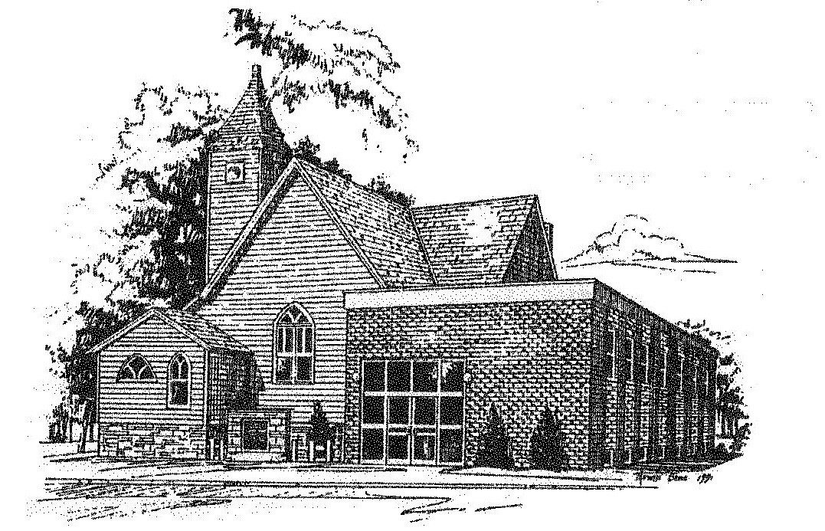

Established in Covenant Faithfulness
September 18, 1892
Member of the
Conservative Congregational
Christian Conference
Since 1964

