The Worship of Our God
Resting in the Renewing Power of God’s Grace

September 20th 2020

The Eighth Sunday in Regular Time

Prelude
Welcome, announcements and Call to Worship

*Opening Hymn #360 “He Giveth More Grace” (G)

Invocation
Passing of the Peace
Leader: May the peace of Christ be with you
People: And also, with you,
Hymn #334 “Be Still My Soul” (G)
Our Confession to God
Our Assurance of Forgiveness
Our Petitions to God
Pastoral Prayer / The Lord’s Prayer
Tithes and Offerings

*Confession of Faith “The Apostles Creed” (I)

The Equipping of God’s People

Scripture Psalm 131
Message How to Diffuse A Time Bomb

*Closing Hymn: #332 “All Will Be Well” (G)
Benediction
Postlude

Pastor Jonathan Faulkner
Accompanist: Kathi Nelson, Phyllis Shortenhaus, Rachel Faulkner & Mary Haakenson
The People of God, Ministers to the World
*Indicates standing (G) Green Hymnal (P) Purple Chorus Book (I) Insert

Welcome! We are so thankful that you could join us today! May our hearts and minds be shaped into greater conformity with Jesus as we worship together. We are delighted to serve you as we love one another in Christ.

Faithful in Prayer
Praise the Lord for…
- His grace in preaching, prayer, the sacraments & fellowship
- The beauty of creation & His divine imprint on all that He has made
- His powerful & life-giving Word

Hospitalized, Sick or Shut-in
* Marlyn Hanson
* Jan Missman
- Jenny Frerichs
- Leone Milbrandt
- Carol Malmberg
- Larry Dirksen
- The family of Joe Berschman
- Jack Jutting
- Chuck Silber
- Virgil Hefner
- Megan Vick (Rachel’s Cousin)
- Barb Weaver
- Connie Berhow
- Billy Smith
- Margaret Whitson (Pastor Faulkner’s Grandmother)
- Scott Whitson (Pastor Faulkner’s Uncle).
- Richard Heyes
- Travis Stohr
- Kim Enright
- Jeff Buege
- Colt (Paul and Cheryl Beenken’s Grandnephew)

Mission Partners of the Month: Beth and Sally Donjte
Day to Day
- Revival, reconciliation and reformation in our land, community & families
- Governing authorities & our Country
- Strong marriages committed to the Lord and to maturing in Christ
- Those recovering from surgery & treatment for illnesses
- Wisdom as parents & grandparents committed to raising children in the fear and instruction of the Lord

Looking Ahead
Today
9AM Worship Service (available in-person and ).

Pastoral Thought: Where is our faith? In talking with many Christians, not just in our church but all over town I have been confronted by a negativity towards the situations we all find ourselves in. Part of that is grief, we miss each other, we miss the commonality of worship in our Church buildings, we miss Communion. But there is something else here too, that is that the people of God have become increasingly discouraged by the state of our world. That is understandable, but let us not forget that God has promised, through Jesus, that these things would happen and in fact would be the norm. The eyes of the saints then, were to be focused upward, towards God the father and doing what He has called us to do, lest we become like Peter and look at the wind and waves and begin to drown. Christians should share in a certain amount of optimism that comes to us through the Spirit and knowing the outcome of history. Satan, on the other hand, is intent on stealing our optimism and our hope through discouraging us. When we let that discouragement take over and make us apathetic or even bitter, we are letting Satan win in our personal lives, something we are to fight hard against. So stand firm Church, in what you have heard and seen in Scripture and trust that God can do what He says He will do. He has not failed us in 130 years, why would He start now?

Giving has been moved to the weekly Newsletter and Announcements insert, to receive this Newsletter by mail or by email, please call the Church Office or email Pastor Faulkner at jon.faulkner.arl@gmail.com.

Member of the Conservative Congregational Christian Conference
www.firstcongobc.com / www.godsheartforthose.com

First Congregational Church
Buffalo Center, Iowa

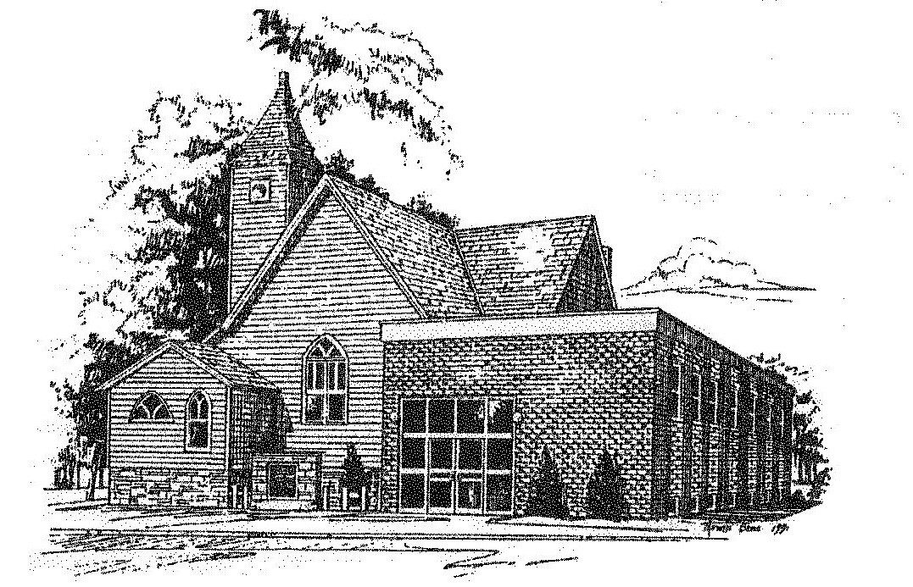

Loving God, Loving People, Making Disciples

Established in Covenant Faithfulness
September 18, 1892
Member of the
Conservative Congregational
Christian Conference
Since 1964

